Name | Roll Number
Aiman Naqvi | 21F-9308
Muhammad Ali Mustafa | 21F-9088

ENTREPRENEURSHIP PROJECT
Title:
Sentiment Analysis of Customer Comments on Pakistani Fashion Brands

- Introduction:
In today’s digital-first world, customer feedback on social media holds substantial value for brands. Our project explores this very aspect—how customers feel about prominent Pakistani fashion brands. Using publicly available data from social media, we conducted sentiment analysis on user comments related to well-known names like Khaadi, Gul Ahmed, Sapphire, J., and Bonanza Satrangi.

- Project Overview:
Our project centers around analyzing real-time feedback from customers using a sentiment analysis model. We gathered textual comments from Facebook and Twitter, cleaned and prepared them, applied sentiment classification using VADER (a lexicon and rule-based sentiment analysis tool), and visualized the results to uncover patterns in public perception.
The work was done in Python using a Jupyter Notebook, keeping the tools open-source and accessible for others who may want to extend this project in the future.

- Objectives:
- To collect and process social media comments on Pakistani fashion brands.
- To apply sentiment analysis using VADER from the NLTK library.
- To visualize sentiments over time and across brands.
- To derive insights into customer satisfaction, concerns, and expectations.
- To propose recommendations for business improvements

- Target Audience:
This project targets both academic and business audiences. On the academic side, it serves as a practical implementation of data analytics techniques. For businesses—especially marketing and product teams at fashion brands—the findings can help in making customer-centric decisions.

- Methodology:
Tools & Environment
- Python 3 in a Jupyter Notebook
- Libraries Used:
- pandas, nltk, matplotlib, seaborn, wordcloud, emoji
- Sentiment scoring was done using VADER from NLTK.

- Data Collection:
We used a .csv dataset named pakistani_fashion_comments.csv containing social media comments. The dataset included:
- brand: Brand name (e.g., J., Sapphire)
- text: The actual customer comment
- created_at: Timestamp of the comment
- platform: Source (Facebook or Twitter)
- language: Mostly English with some Roman Urdu

- Preprocessing Steps:
- Removed URLs, mentions, hashtags
- Removed emojis
- Converted text to lowercase
- Removed stopwords (both English and Roman Urdu)
- Filtered short/meaningless words
A clean_text() function handled this, and clean results were stored in a new column.

- Sentiment Classification:
- VADER produced a compound score for each comment.
Sentiments were classified as:
- Positive if score > 0.05
- Negative if score < -0.05
- Neutral otherwise
The results showed an approximate distribution of 250 positive, 200 neutral, and 50 negative comments. This indicates that a significant majority of customers hold favorable views, with only a small fraction expressing dissatisfaction. The neutral responses suggest an average or indifferent experience, while the negative portion identifies areas that may benefit from targeted improvements.
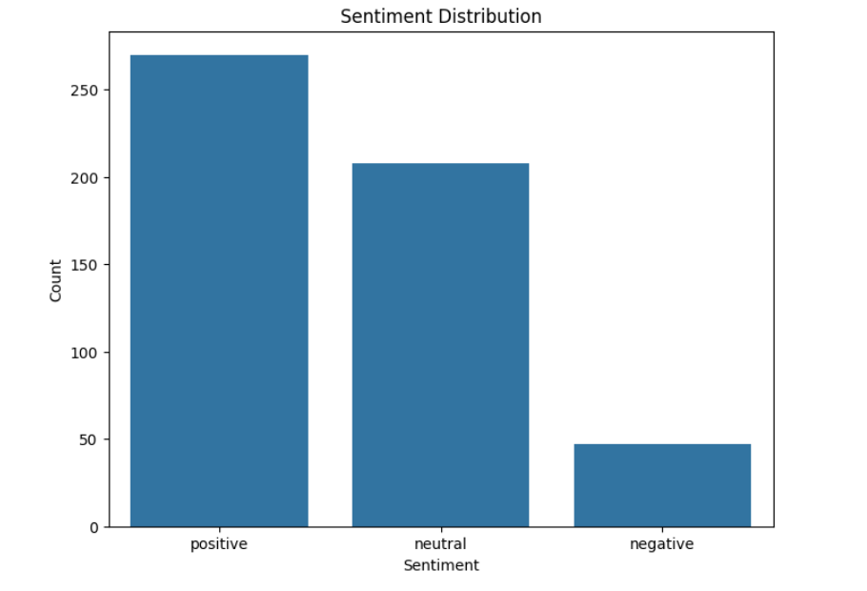
- Sentiment Trend Overtime:
A line graph illustrates how customer sentiments—positive, neutral, and negative—fluctuated month by month. This trend highlights changes in public perception over time, possibly influenced by seasonal events or brand campaigns.
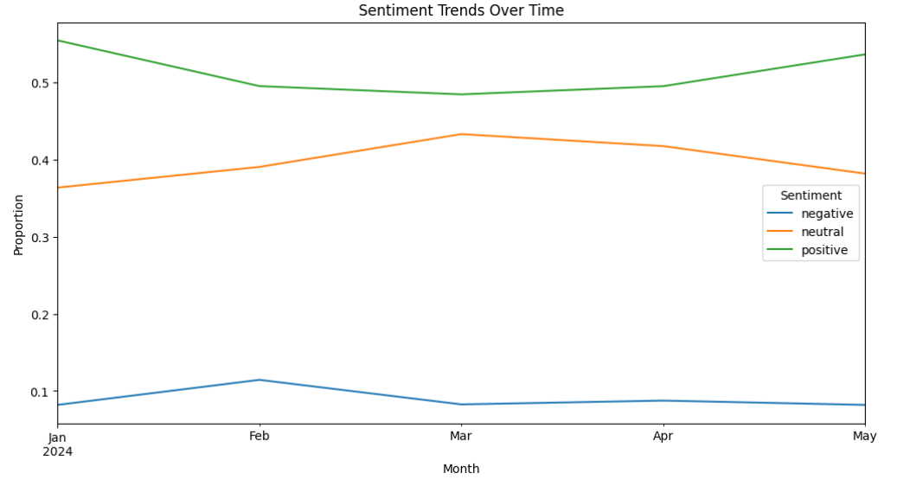
- Brand-wise Sentiment Mix:
The graph represents the sentiment distribution (positive, negative, and neutral) for each of the eight analyzed Pakistani fashion brands: Alkaram, Bonanza Satrangi, ChenOne, Gul Ahmed, J., Khaadi, Nishat Linen and Sapphire. It visually illustrates the proportion of customer sentiments for each brand, allowing for a clear comparison of customer perceptions across the brands.
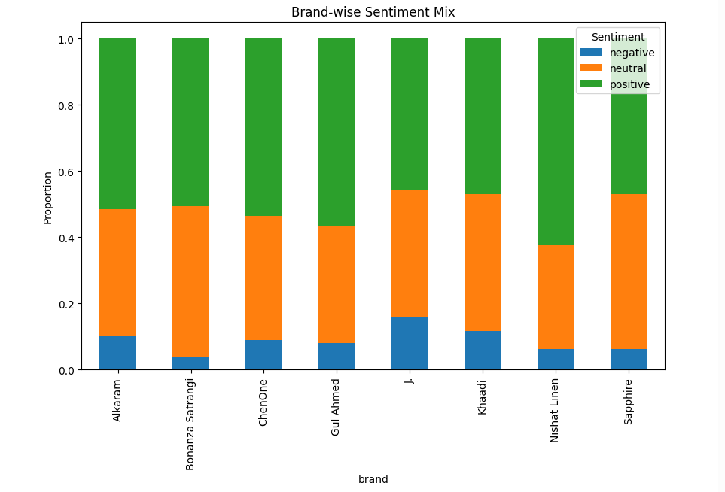

- Platform-wise Sentiment:
The graph illustrates how customer sentiments are distributed across three major social media platforms: Facebook, Instagram, and Twitter. It highlights variations in positive, neutral, and negative feedback on each platform, offering insights into where users express the most satisfaction or concerns.
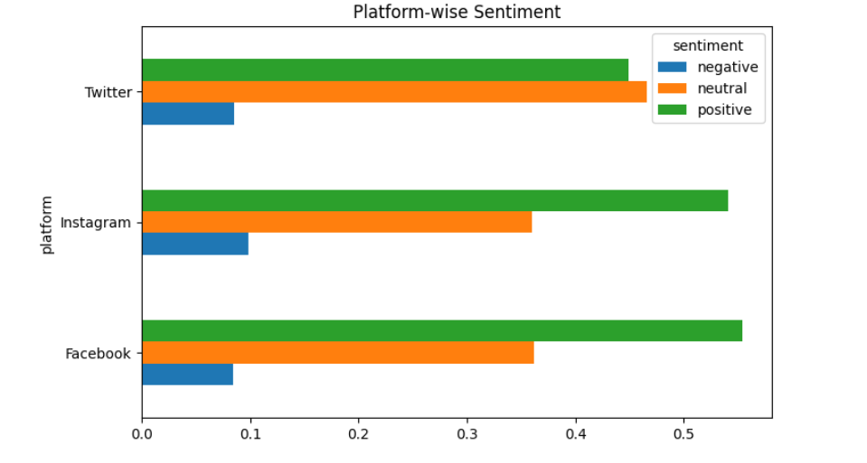

- Keyword Analysis:
To identify key factors influencing customer sentiment, we analyzed the most frequent words and common word pairs (bigrams) in positive and negative comments.
Positive keywords highlighted aspects like product quality, design, and overall satisfaction, while negative keywords pointed to issues such as delivery delays, website problems, and customer service concerns.
Common bigrams in positive comments included phrases like “great quality” and “fast delivery,” whereas negative ones featured “late delivery” and “website crashed,” offering deeper insight into recurring customer experiences.

- Word Cloud Visualization:
To complement the keyword analysis, we generated word clouds for both positive and negative comments. Word clouds provide a visual summary of the most prominent terms based on their frequency.
- The positive word cloud emphasizes terms such as “beautiful,” “quality,” “modern,” and “perfect,” reflecting appreciation for product design, aesthetics, and overall satisfaction.
- The negative word cloud highlights concern through words like “delayed,” “issue,” “return,” and “poor,” which point to logistical or service-related challenges that customers face.
These visualizations offer an intuitive overview of the language customers use when expressing praise or complaints, aiding in the identification of key focus areas for brand improvement.
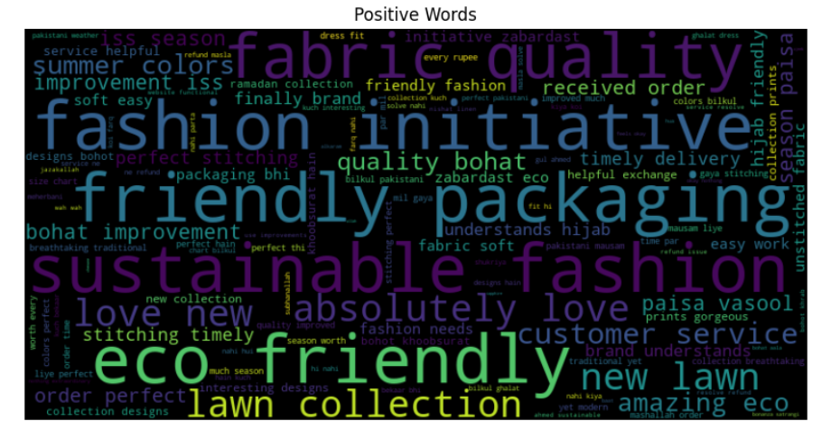
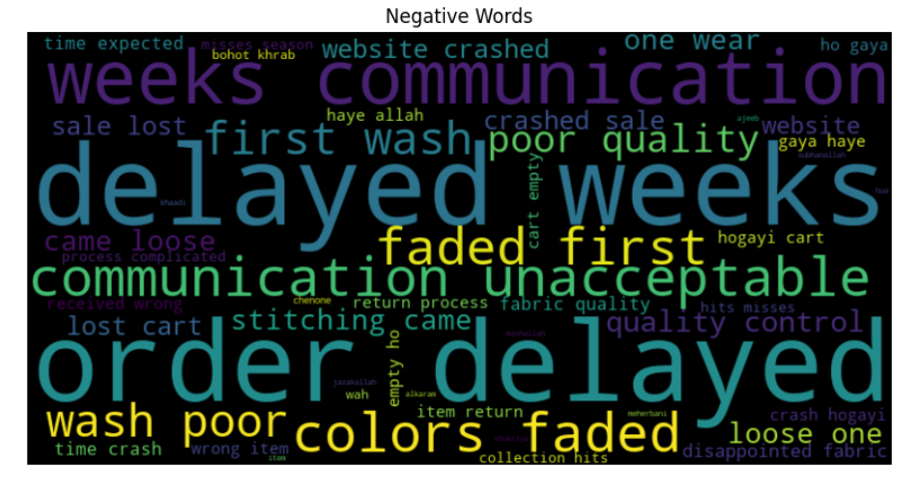

- Project Process:
Completed Tasks:
- Installed and set up the environment
- Cleaned and preprocessed data
- Applied VADER sentiment analysis
- Visualized sentiment distribution and time-based trends
- Generated word clouds for positive and negative feedback

Challenges:
- Dealing with Roman Urdu mixed with English in the same comments.
- Lack of large labeled datasets made supervised learning impractical.
- Emojis often carried meaning, but removing them was necessary for uniformity.
- Noise in social media text made cleaning slightly complex.

- Future Insights:
To enhance customer satisfaction, fashion brands should address recurring issues such as website glitches, delivery delays, and customer service responsiveness. Strengthening digital experiences and highlighting positive aspects like quality and design in marketing can build stronger brand loyalty. Future analysis using larger datasets and advanced models can offer deeper insights into evolving customer preferences.

- Conclusion:
This project successfully demonstrates the power of sentiment analysis in understanding customer perceptions of leading Pakistani fashion brands. By collecting and processing real user comments from social media, we were able to identify patterns in sentiment, brand-specific strengths and weaknesses, and platform-level engagement differences. The insights derived from keyword trends, sentiment fluctuations over time, and word cloud visualizations highlight not only customer appreciation for quality and design but also recurring concerns related to delivery and service. These findings can guide fashion brands toward more informed, customer-focused decisions.

